PRODUCT DISSECTION CASE STUDY
NETFLIX
Schema Design & Data Architecture Behind the World's Leading Streaming Platform

Table of Contents
- Executive Summary
- Step 1 — Platform Selection: Why Netflix
- Step 2 — Research: Core Features & Functionality
- Step 3 — Product Dissection: Real-World Problems Solved
- Step 4 — Case Studies: Problems in Action
- Step 5 — Schema Design: Entities, Attributes & Relationships
- Step 6 — Rationale Behind the Design
- Step 7 — Entity-Relationship Diagram
- Step 8 — Presentation Notes & Closing Summary

Introduction
Every time you open Netflix, hit play, and pick up a show exactly where you left off — on a completely different device — there's a massive data architecture working behind the scenes to make that feel effortless. That invisible complexity is exactly what this case study is about.
For this project, I chose to dissect Netflix: the world's leading subscription streaming platform, serving over 300 million paid memberships across more than 190 countries. I picked Netflix specifically because it stacks several layers of product and data complexity into one experience. There's subscription commerce — plans, billing cycles, regional pricing. There are multi-tenant households, where one account supports up to five completely independent profiles, each with its own taste and viewing history. There's a deep content hierarchy, where a single title can branch into seasons and then individual episodes. And running underneath all of it is a real-time personalization engine — recommendations, continue-watching, 'Top 10' rows — that reportedly drives about 80% of everything people actually watch.
Here's how I'm going to walk through it. First, I'll research and break down the core features that define the Netflix experience — things like multi-profile accounts, continue watching, thumbs-up ratings, and offline downloads. Then I'll connect each of those features back to a real-world problem it's actually solving — because a feature only makes sense once you understand the pain point behind it.
From there, I'll walk through four detailed case studies — real scenarios, like a family sharing one account with very different viewing habits, or a user picking up an episode on their phone after pausing it on their TV — and show exactly how Netflix's design handles each one.
Finally, I'll get into the actual schema design: thirteen core entities, from Users and Subscription Plans, to Profiles and Devices, all the way through to Titles, Episodes, Ratings, and Recommendations — plus a full Entity-Relationship diagram tying it all together, and the rationale behind why each design decision was made the way it was.
By the end of this video, you'll see that schema design isn't just a backend implementation detail — it's the direct reason features like Continue Watching and personalized recommendations are possible at all. Let's get into it

Executive Summary
Netflix is the world's leading subscription streaming platform, serving over 300 million paid memberships across more than 190 countries. What looks to a viewer like a simple “press play” experience is, underneath, one of the most sophisticated data architectures in consumer technology — coordinating billing, per-person personalization, a global content catalog, adaptive video delivery, and a recommendation engine that drives an estimated 80% of viewing hours.
This case study dissects Netflix as a product, identifies the real-world problems its core features solve, and reverse-engineers a relational schema design that could plausibly power those features. The schema is built around eight core entities — User, Subscription Plan, Payment, Profile, Device, Title, Season/Episode, and the activity tables that connect them (Watch History, My List, Rating, Recommendation) — and is presented with a full Entity-Relationship diagram, attribute-level tables, and the design rationale behind each decision.
The goal of this document is to demonstrate how thoughtful data modeling directly enables product outcomes: fast personalized homepages, accurate recommendations, seamless multi-profile households, and reliable billing at global scale.

Step 1 — Platform Selection: Why Netflix
Netflix was selected for this case study because it combines several layers of product and data complexity in one platform:
- Subscription commerce — plans, billing cycles, payment retries, and regional pricing.
- Multi-tenant households — a single account supports multiple independent “profiles,” each with its own taste graph.
- A deep content hierarchy — titles that branch into seasons and episodes, each with its own metadata and media assets.
- Real-time personalization — recommendations, continue-watching, and “Top 10” rows that must update as behavior changes.
- Massive scale — hundreds of millions of users and tens of thousands of titles, which forces deliberate choices about normalization, indexing, and denormalization for read speed.
These layers make Netflix an ideal subject for schema design: almost every consumer product problem (auth, billing, catalog, personalization, multi-device sync) appears somewhere in its data model.

Step 2 — Research: Core Features & Functionality
The table below summarizes the features that define the Netflix user experience and are most relevant to schema design.
Feature | What it does | Why it matters to users
Multi-profile accounts | Up to 5 profiles per household account, each with its own history, list, and recommendations. | Lets each family member get a personal experience without separate subscriptions.
Continue Watching | Resumes playback exactly where a user left off, per profile and per device. | Removes friction from returning to long-form content across sessions.
Personalized recommendations | Machine-learning-driven rows (“Because you watched…”, “Top 10 in your country”). | Helps users find relevant content in a catalog of thousands of titles.
My List / Watchlist | Lets a profile bookmark titles to watch later. | Supports intent capture across browsing sessions.
Thumbs Up / Down ratings | Lightweight binary feedback used to refine recommendations. | Low-friction way to train personalization without surveys.
Downloads for offline viewing | Caches an episode/title locally on a specific device for a limited window. | Enables viewing without connectivity (flights, commutes, limited data).
Adaptive streaming & multi-device sync | Tracks playback position and device context to resume seamlessly anywhere. | Consistent experience across TVs, phones, browsers, and consoles.
Subscription tiers & billing | Multiple plans (e.g., Standard with Ads, Standard, Premium) with different price, quality, and screen limits. | Lets Netflix monetize different willingness-to-pay segments.
Global catalog & licensing windows | Titles, availability, and maturity ratings vary by region and time. | Supports regional content law and licensing deals.

Step 3 — Product Dissection: Real-World Problems Solved
Each feature above exists because it solves a specific, recurring real-world problem. Framing features this way is the bridge between product thinking and schema design — the schema must be able to represent the problem before it can support the solution.

Problem 1: Households share an account but not a taste
A family sharing one login would otherwise see one blended, incoherent set of recommendations and one shared watch history. Netflix solves this with independent PROFILE records under a single USER (account), each carrying its own maturity settings, history, and personalization state.

Problem 2: Users abandon and resume content unpredictably
Long-form video is rarely watched in one sitting, and increasingly across multiple devices. The WATCH_HISTORY entity, keyed by profile and episode with a stored playback position, is what makes “Continue Watching” and cross-device resume possible.

Problem 3: A catalog of thousands of titles is too large to browse manually
Choice overload is a well-documented driver of user drop-off. The RECOMMENDATION and RATING entities, combined with the GENRE/TITLE_GENRE relationship, let Netflix's ranking models surface a small, relevant subset of the catalog to each profile.

Problem 4: Global users need different pricing, quality, and access rules
A single flat global price ignores purchasing-power differences and device capability differences (SD vs. 4K households). The SUBSCRIPTION_PLAN entity, linked to USER and PAYMENT, encodes price, quality tier, and screen-count limits so the same platform can serve very different markets.

Problem 5: Content licensing is time-bound and territory-bound
A title Netflix can show in one country may not be licensed in another, and rights can expire. Attributes on TITLE (region availability, licensing window) allow catalog visibility to be filtered without duplicating the platform per country.

Problem 6: Viewers want to watch without an internet connection
Mobile data limits and travel scenarios created demand for offline playback. A DOWNLOADED_CONTENT-style relationship (modeled here as an extension of DEVICE + EPISODE) tracks what's cached locally and when it expires, balancing user convenience against content-protection requirements.

Step 4 — Case Studies: Problems in Action
This section walks through concrete, scenario-based examples of the problems above and how Netflix's design — and by extension, its underlying schema — resolves them.

Case Study A: The Shared Family Account
Scenario: The Ramirez family has one Netflix account. The parents watch true-crime documentaries at night; their 8-year-old uses a kids' profile in the afternoon.
- Without profile separation: the recommendation row on the shared home screen would mix crime documentaries with children's cartoons, and the child could stumble into mature content or a mature watch history.
- With the schema's PROFILE entity: each profile has its own is_kids flag, maturity_lvl, WATCH_HISTORY rows, and RECOMMENDATION rows, so the two experiences never leak into each other, even though PAYMENT and SUBSCRIPTION_PLAN remain shared at the USER level.

Case Study B: Cross-Device Continue Watching
Scenario: A user starts an episode on their living-room TV, pauses at the 20-minute mark, then opens the Netflix app on their phone during a commute.
- The WATCH_HISTORY row for that (profile_id, episode_id) pair stores progress_sec and a timestamp, independent of which DEVICE recorded it.
- When the phone app requests “continue watching” for that profile, it queries the most recent WATCH_HISTORY row for that episode rather than relying on local device storage — this is only possible because playback state lives in the shared schema, not on the device.

Case Study C: Surfacing the Right Title in a 15,000-Title Catalog
Scenario: A profile has given thumbs-up ratings to several sci-fi titles and frequently rewatches superhero content.
- RATING rows for that profile, joined against TITLE_GENRE, let a recommendation model infer an affinity for the “Sci-Fi” and “Superhero” genre_ids.
- The RECOMMENDATION entity stores a match_score per (profile_id, title_id) pair, refreshed by an offline batch job (algo_version), which is what powers personalized rows like “Because you watched…” without recomputing scores on every page load.

Case Study D: Regional Pricing and Plan Changes
Scenario: A user on the ad-supported “Standard with Ads” plan upgrades to “Premium” to unlock 4K streaming and a 4th simultaneous screen ahead of a family trip.
- The USER.plan_id foreign key updates to point at the new SUBSCRIPTION_PLAN row, and a new PAYMENT row is created reflecting the prorated charge.
- Because video_quality and max_screens live on SUBSCRIPTION_PLAN rather than being hardcoded per user, Netflix can introduce, retire, or reprice plans (as it has repeatedly done) without altering the USER table's structure — a direct product benefit of normalizing plan data out of the account record.

Step 5 — Schema Design: Entities, Attributes & Relationships
The schema below focuses on the entities required to support the features dissected above. Primary keys are marked PK and foreign keys FK. Data types are illustrative (a real implementation would refine precision, e.g., DECIMAL for currency).

USER
Attribute | Type | Notes
PK user_id | BIGINT | Unique account identifier
email | VARCHAR(255) | Unique; used for login & billing notices
password_hash | VARCHAR(255) | Never stored in plaintext
name | VARCHAR(120) | Account holder's name
signup_date | DATE | Used for cohort analysis & tenure
region | VARCHAR(60) | Drives catalog & pricing localization
FK plan_id | BIGINT | Current active subscription plan

SUBSCRIPTION_PLAN
Attribute | Type | Notes
PK plan_id | INT | Unique plan identifier
plan_name | VARCHAR(60) | e.g., Standard with Ads, Premium
price | DECIMAL(6,2) | Monthly price in local currency
max_screens | TINYINT | Simultaneous streams allowed
video_quality | VARCHAR(20) | SD / HD / 4K+HDR

PAYMENT
Attribute | Type | Notes
PK payment_id | BIGINT | Unique transaction identifier
FK user_id | BIGINT | Account being billed
FK plan_id | INT | Plan active at time of charge
amount | DECIMAL(8,2) | Amount charged
payment_date | DATETIME | Timestamp of the transaction
status | VARCHAR(20) | success / failed / refunded

PROFILE
Attribute | Type | Notes
PK profile_id | BIGINT | Unique profile identifier
FK user_id | BIGINT | Parent account (max 5 profiles/account)
profile_name | VARCHAR(60) | Display name shown on profile picker
avatar | VARCHAR(255) | Avatar image reference
is_kids | BOOLEAN | Restricts catalog to kid-appropriate titles
maturity_lvl | VARCHAR(20) | Content maturity ceiling for this profile

DEVICE
Attribute | Type | Notes
PK device_id | BIGINT | Unique device/session identifier
FK profile_id | BIGINT | Profile most recently active on this device
device_type | VARCHAR(40) | smart_tv / mobile / browser / console
last_active | DATETIME | Last time this device streamed content

TITLE
Attribute | Type | Notes
PK title_id | BIGINT | Unique content identifier
name | VARCHAR(255) | Display title
type | VARCHAR(10) | movie / series
release_yr | SMALLINT | Original release year
maturity_rating | VARCHAR(10) | e.g., PG-13, TV-MA
synopsis | TEXT | Short description shown on the title card

SEASON
Attribute | Type | Notes
PK season_id | BIGINT | Unique season identifier
FK title_id | BIGINT | Parent series
season_num | SMALLINT | Season ordering within the series

EPISODE
Attribute | Type | Notes
PK episode_id | BIGINT | Unique episode identifier
FK season_id | BIGINT | Parent season
ep_num | SMALLINT | Episode ordering within the season
duration | INT | Runtime in seconds
video_url | VARCHAR(500) | Reference to the encoded media asset

GENRE
Attribute | Type | Notes
PK genre_id | INT | Unique genre identifier
genre_name | VARCHAR(60) | e.g., Sci-Fi, Anime, Superhero, Drama

TITLE_GENRE (junction table)
Attribute | Type | Notes
FK title_id | BIGINT | Composite key part 1
FK genre_id | INT | Composite key part 2 — resolves the title–genre M:M relationship

WATCH_HISTORY
Attribute | Type | Notes
PK history_id | BIGINT | Unique viewing-event identifier
FK profile_id | BIGINT | Who was watching
FK episode_id | BIGINT | What was watched (episode-level, even for movies via a synthetic single-episode record)
progress_sec | INT | Playback position at last update — powers Continue Watching
timestamp | DATETIME | Last update time

MY_LIST
Attribute | Type | Notes
PK list_id | BIGINT | Unique bookmark identifier
FK profile_id | BIGINT | Profile that saved the title
FK title_id | BIGINT | Saved title
added_date | DATE | When it was added, for sort order

RATING
Attribute | Type | Notes
PK rating_id | BIGINT | Unique rating identifier
FK profile_id | BIGINT | Who rated it
FK title_id | BIGINT | What was rated
thumbs_score | TINYINT | -1 (down) / +1 (up) / +2 (double thumbs-up)
timestamp | DATETIME | When the rating was given

RECOMMENDATION
Attribute | Type | Notes
PK rec_id | BIGINT | Unique recommendation-record identifier
FK profile_id | BIGINT | Who the recommendation is for
FK title_id | BIGINT | Recommended title
match_score | DECIMAL(5,2) | Model-generated relevance score, e.g., “97% Match”
algo_version | VARCHAR(20) | Which model/version produced the score, for A/B testing

Relationship Summary
Relationship | Cardinality | Meaning
USER → SUBSCRIPTION_PLAN | M : 1 | Many accounts can share the same plan tier
USER → PAYMENT | 1 : M | One account generates many billing transactions over time
USER → PROFILE | 1 : M (max 5) | One account contains up to five independent profiles
PROFILE → DEVICE | 1 : M | A profile can be active on many devices
PROFILE → WATCH_HISTORY | 1 : M | A profile accumulates many viewing events
PROFILE → MY_LIST | 1 : M | A profile can bookmark many titles
PROFILE → RATING | 1 : M | A profile can rate many titles
PROFILE → RECOMMENDATION | 1 : M | A profile receives many scored recommendations
TITLE → SEASON | 1 : M | A series contains many seasons (0 for a movie)
SEASON → EPISODE | 1 : M | A season contains many episodes
TITLE ↔ GENRE | M : M (via TITLE_GENRE) | A title can span multiple genres; a genre spans many titles
WATCH_HISTORY → EPISODE | M : 1 | Many viewing events reference the same episode across users

Step 6 — Rationale Behind the Design

Why separate USER and PROFILE?
Billing, identity, and security concerns (email, password, payment method) belong to the account holder, while taste, history, and content restrictions belong to the individual viewer. Splitting these into two entities means a plan upgrade never touches five rows of personalization data, and a family member’s profile can never accidentally access the account's payment information.

Why is SUBSCRIPTION_PLAN its own entity rather than columns on USER?
Plans change over time (new tiers are added, prices change by region) independently of any single user. Normalizing plan data lets Netflix run pricing experiments and roll out new tiers as data changes, not schema changes.

Why model TITLE, SEASON, and EPISODE as three levels instead of one flat table?
Movies and series behave differently: a movie is a single playable asset, while a series has an open-ended, growing hierarchy. Three levels let a new season or episode be added without altering the parent TITLE row, and let attributes that only make sense at one level (e.g., ep_num) live where they belong.

Why is TITLE_GENRE a separate junction table instead of a genre column on TITLE?
A single title routinely belongs to multiple genres (a film can be both “Sci-Fi” and “Action”). A many-to-many relationship cannot be represented as a single column without violating normalization, so a junction table is the standard resolution.

Why store progress_sec on WATCH_HISTORY instead of only a boolean “watched” flag?
Continue Watching is one of Netflix's most-used features, and it requires resuming at an exact position, not just knowing that a title was opened. Storing granular progress is what makes that feature possible.

Why give RECOMMENDATION its own table instead of computing scores on the fly?
Recommendation scoring is computationally expensive and typically runs as a batch/offline machine-learning job. Persisting the output (match_score, algo_version) lets the homepage render instantly from a simple lookup instead of recomputing a model in real time for every page view, and the algo_version column supports safely A/B-testing new models.

Why keep RATING separate from RECOMMENDATION even though both relate a profile to a title?
RATING is a raw, user-provided signal (an input); RECOMMENDATION is a derived, system-generated output. Keeping them separate preserves a clean distinction between ground-truth user feedback and model predictions, which is essential for retraining and auditing the recommendation system over time.

Step 7 — Entity-Relationship Diagram
The diagram below visualizes every entity in Section 5 along with primary keys (PK), foreign keys (FK), and the cardinality of each relationship.
=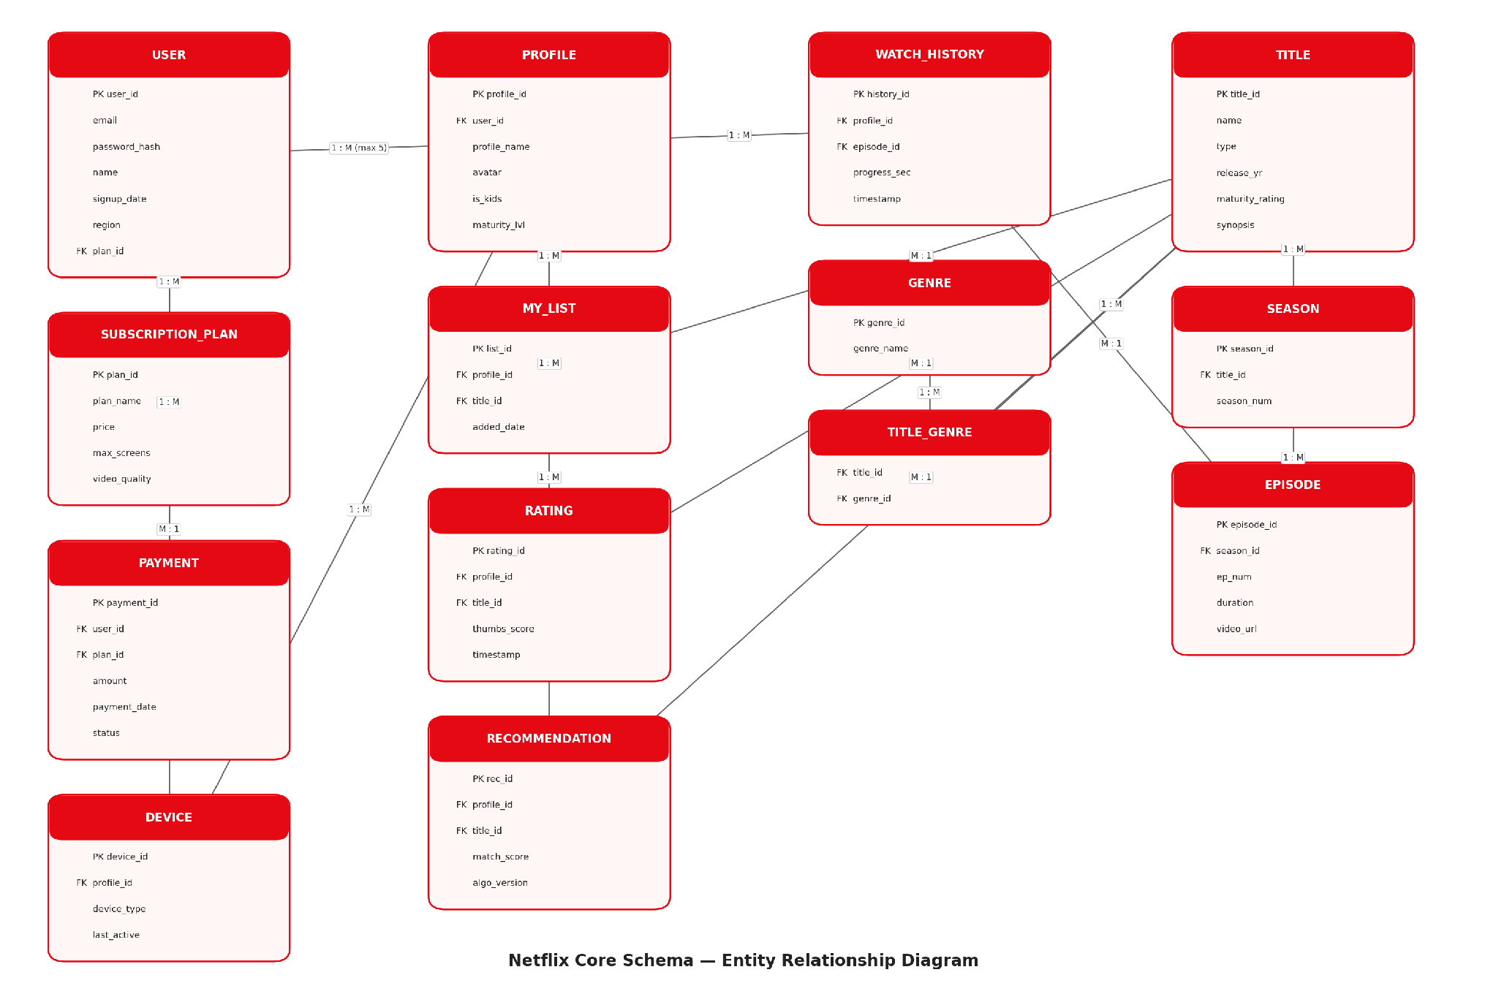
Figure 1. Entity-Relationship diagram of the Netflix core schema (account/billing, profile/personalization, activity, and content-catalog clusters).

Closing Summary
Netflix's product experience — seamless per-person personalization, uninterrupted cross-device playback, and a catalog that feels curated rather than overwhelming — is only possible because of deliberate data architecture decisions: separating identity from personalization, normalizing subscription and content metadata, and persisting both raw signals (ratings, watch history) and derived outputs (recommendations) as first-class entities. This case study shows that schema design is not a back-office implementation detail; it is a direct enabler of the product's most valued features.

